David Swann
david@motupohue.nz
Healing Hills
STATUS REPORT 2025

Abstract
This document reports on BHMET’s activities in 2025.
Contents
Executive Summary –Healing Hills 2
Predator Control 3
Overview 3
Comparison between trap types 3
Manual Trap Statistics 4
Goodnature A24 Results 5
AT220 Results 6
AT520 Traps 7
Deployment 8
Data Collection 8
AI Performance 8
Trap Performance 10
Comparison of Results 12
AT110 Trial 12
Monitoring 13
AT520-AI Traps 13
Trap Interactions Analysis 13
Shan0600CM(CAM625) 14
Motu1300CM(CAM487) 15
Taur0070CM(CAM589) 17
BLine0550CM(CAM416) 18
Interaction Analysis Conclusions 19
Yarn AI Trail Cams 19
Cacophony AI Bird Monitor 20
Nursery Operations 20
Planting 20
Current Planting Season 20
Past Plantings 21

BHMET Status Report 2025

Executive Summary –Healing Hills
Motupōhue is healing. We have achieved record low levels of predator activity and our ngahere and its manu are thriving once again.
During the year, BHMET took over the assets and functions of the Omaui Landcare Charitable Trust. That means that BHMET now looks after a second hill: Omaui at the other end of Tārere ki Whenua Uta – the peninsula that connects Motupōhue and Omaui. Thanks to over 12 years of effort by OLCT, Omaui is also healing and their team of volunteers continues to work tirelessly.
In 2025, BHMET was with funding from Trees That Count, backed up by Air New Zealand. That funding has seen 25,000 trees planted on the hill in 2025. After a delay in starting the planting season, the autumn saw perfect planting conditions only blighted by frequent and intense wind events.
Much of the new funding has been used to purchase new AI-based monitoring technology: AI bird monitors from Cacophony; and AI-enabled trail cams for our Yarn Mesh infrastructure. The AI has not performed as we’d anticipated and is not capable of the automatic monitoring that we’d hoped for. This has been a major obstacle in meeting the objectives for 2025. We have worked closely with the vendors to help them understand how to improve their technology.
The AT520 traps have helped BHMET to better understand AT220 results. There has been a suspicion for some time that our AT220 traps might be over-stating trigger data. This has now been confirmed; our historic results from the AT220 traps have been reporting twice as many triggers as have occurred. Even with this correction, the AT220 (and AT520 traps) still perform far better than any other trap type.
The AT520 traps have required significant manual processing of data. The dense, real-time monitoring network that these traps enable has been extremely useful but is too labour-intensive at present; significant improvements in the AI capability is required.
Despite the manual processing, the monitoring results have been insightful. They confirm the low predator numbers across the hill. Possum and rat numbers are at record low numbers.
The remaining predators are very cautious in their trap interactions. We have observed an interaction to kill ratio at over 25:1 (twenty-five interactions produce one kill at that trap). This illustrates the challenge of late-stage trapping.
Stoats remain a challenge. Stoats move during the day and so beat the daytime safe mode of the AT220 and AT520 traps. The trials of the new AT110 prototype trap from NZ Autotraps have not been as successful as we hoped for. They have been catching stoats at about the same rate as DOC200 boxes… and we know from camera monitoring that there are many more stoats on the hill.

Predator Control

Overview
BHMET operates three distinct trap fleets on the hill: approximately 1,000 manual traps, approximately 400 Goodnature A24 automatic rat and stoat traps; and 200 NZ Autotraps AT220/AT520 traps.
These traps all have very different reporting mechanisms and BHMET records results from these traps very differently:
- Manual trap results are recorded in the Trap.NZ application and explicitly record the carcass species.
- 85 of our 400 A24 traps use the ‘SmartCap’ device which records the total number of triggers. These triggers are a mix of rats, mice, stoats and weasels and do not get recorded in Trap.NZ unless a carcass is found. However, we exclude these A24 kills from our manual trap statistics
- Results from our AT220 traps are downloaded during the six-monthly service visits. These categorise kills into ‘large’ kills (typically possums) and ‘small’ kills (a mix of rats, mice, stoats and weasels. These kills are not recorded in Trap.NZ unless a carcass is found under the trap. We exclude these AT220 kills from our manual trap statistics
- Now that we have enough AT520 traps deployed, these will start producing definitive data about species that interact with and are killed by the traps. We anticipate producing the first statistics in August 2025.

Comparison between trap types
The results for the different trap types can be compared using the ‘Corrected Catch Rate’ statistic: the number of kills/trap in a 100 night period. For automatic traps, this is straightforward. Between 1st July & 31st December, there are 184 trap nights. For manual traps, it is a little more complicated because once a kill has occurred, the trap isn’t available for the remainder of that trap cycle. Trap.NZ therefore takes the time between trap services that have resulted in a kill and then assumes that the kill occurred halfway through the period: therefore, there were only 50% of trap nights for that period.
The results are summarised here for the period 1 Jul to 31 Dec 2025:
Trap Type | # of Trap Type | Possum CCR | Possum Kills | Possum Kills  / trap | ‘Small’ CCR | Small Kills | Small Kills  / trap | Total CCR | Total Kills | Total Kills  / trap
Manual | 1,031 | - | 7 | - | - | 225 | - | 0.17 | 266 | 0.26
A24 | 139 | - | - | - | 0.88 | 224 | 1.61 | 0.88 | 224 | 1.61
AT220 | 104 | 0.17 | 32 | 0.31 | 6.08 | 1,124 | 10.80 | 6.24 | 1,156 | 11.11
AT520 | 64 | 0.04 | 6 | 0.05 | 4.63 | 296 | 2.54 | 2.52 | 302 | 4.72
It can be seen that the AT220 traps over-perform compared with other traps. As will be seen in the analysis below, there is a suspicion that the AT220s may be generating spurious triggers.

Manual Trap Statistics
The graph below summarises kills from our manual trap fleet over the last three years (1st January 2023 to 31st December 2025). There is a downward trend for all species, despite the ongoing deployment of new traps.
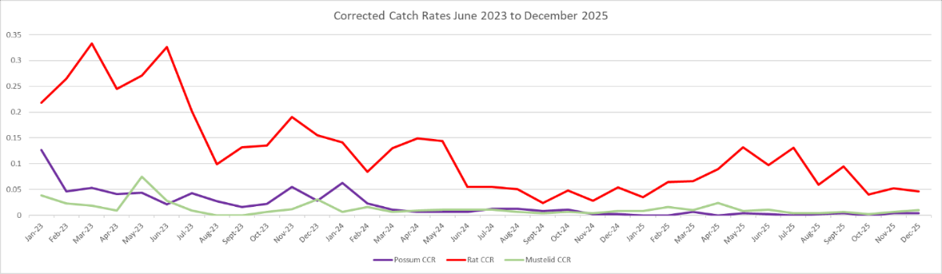
Looking at the distribution of manual trap kills, we observe the following pattern:
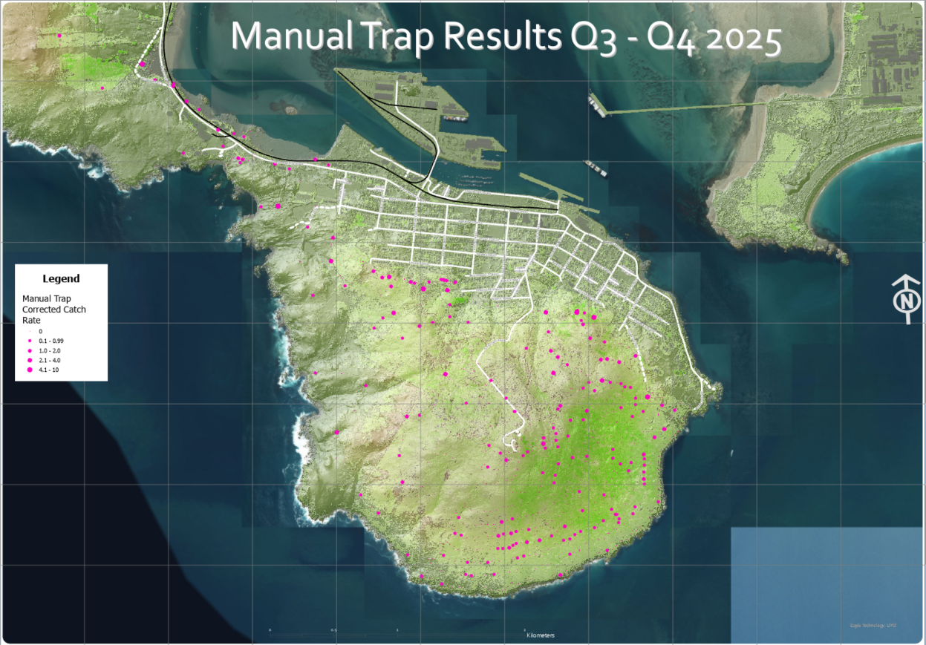
Manual traps dominate in the DOC scenic reserve (southeast quadrant of the hill and at the isthmus. The ICC recreation reserves have sparse manual trap networks and are primarily controlled using automatic trap networks.

Goodnature A24 Results
BHMET operates a fleet of around 400 A24 traps on Motupōhue and another 600 on Omaui. Of these, 100 Motupōhue traps are instrumented with the ‘Smart Cap’ which records triggers. It can be assumed that the results from these traps can be extrapolated over to the rest of the fleet.
The A24 results are shown below:
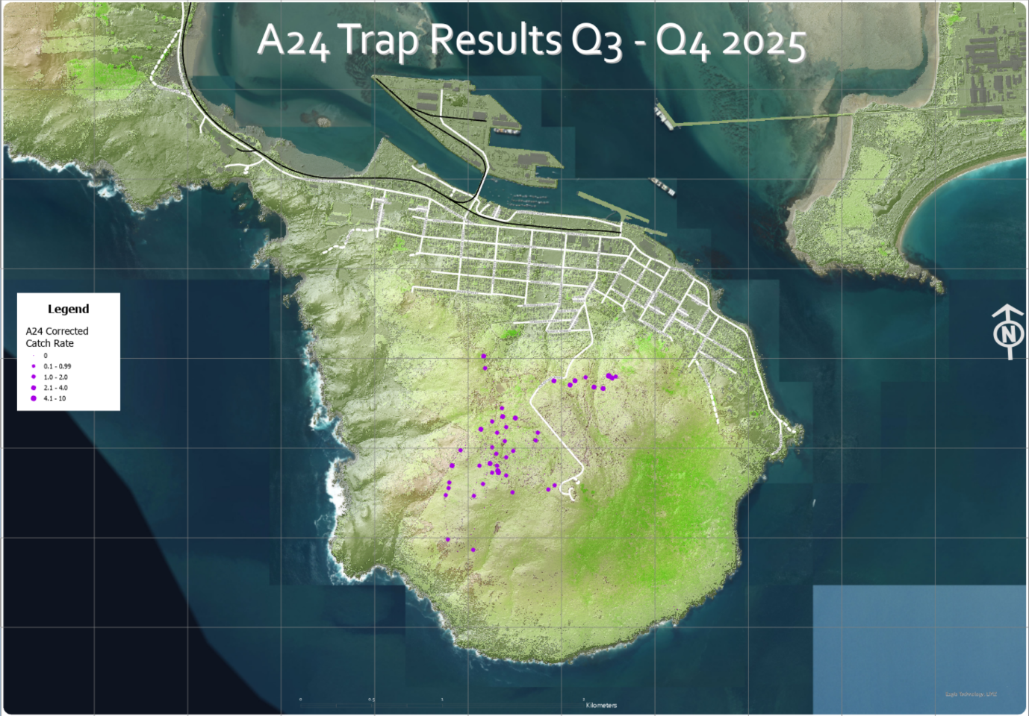
A24s have a consistent CCR of around eight times that of manual traps; the constant availability of these automatic traps makes a real difference.
A challenge that has been reported previously is that it is rare to find carcasses under the A24 traps; inevitably, the carcasses have been removed by other predators.

AT220 Results
The first AT220s were deployed in late 2021. We now have data for 175 AT220s for 4 years. 75 of those AT220s have been upgraded to AT520 traps which have a different data collection and processing mechanism.
AT220 results are collected every 6 months when the traps are serviced. The number of large kills (typically possums) and small kills (rats, mice, mustelids) are recorded for that six-month period. Sophisticated analysis is then done to understand statistics such as kills per 100 trap nights and the rate of decline over time.
The pattern of AT220 corrected catch results can be overlaid onto the earlier maps:
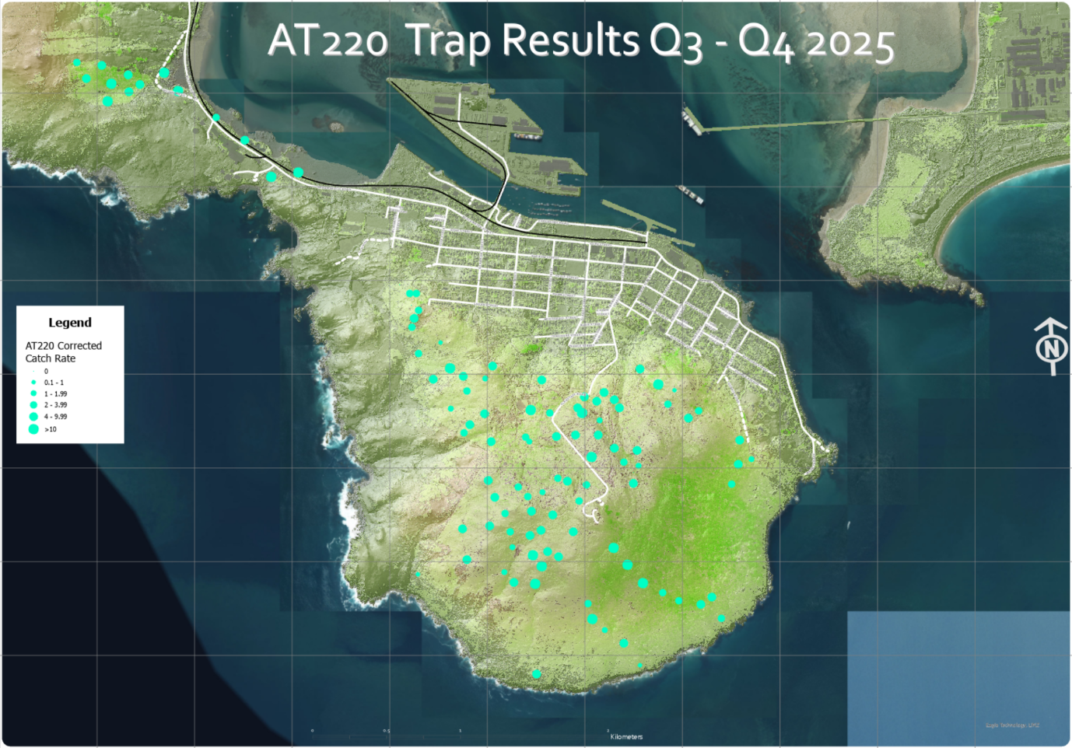
It is important to note the scale change: the AT220 results overwhelm the A24 and manual results – the dots share a common size scale. However, care should be taken in the interpretation of these results.
There was already a suspicion that the AT220 results seemed too high and were not reducing over time. One possibility that had been explored was that there was an excess of waxeye kills when feeding before dawn (and thus beating the daytime safe mode). But this has not been observed in the AT520 traps, despite them operating in AT220 mode (i.e. not using the Species Selective Arming).
BHMET’s AT220s all use older-version trap controllers (referred to as PCBs). The AT520 traps use newer-version PCBs. Our working hypothesis at present is that the older PCBs might be generating the spurious triggers.
It does need to be emphasised that even if the AT220 results are adjusted downwards to mirror the AT520 results, the figures remain far higher than either AT24 or manual traps.

AT520 Traps
The AT520 trap uses the AT220 trap from NZ Autotraps as its core and adds a node from FTP Solutions to add communications and provide AI species identification.
AI is a critical component of the AT520 trap. It promises to support Species Selective Arming (SSA)which protects non-target species from becoming by-catch. It also promises to support monitoring of predator and bird populations across the hill.

Deployment
BHMET first started deploying AT520 traps in August 2024. Unfortunately, the first batch of AT520-AI proved unequal to the fierce Bluff conditions and the nodes failed. FTP Solutions responded quickly to the challenge and produced weather-resistant nodes which started being deployed in December 2025 on a trial basis with 20 traps participating in the three-month trial.
The deployment of the full fleet of AT520-AI traps started in March 2025 and was a lot slower than anticipated. There have been several challenges with the IMS infrastructure and field hardware.

Data Collection
Data from the AT520 traps started being collected in June 2025. It was immediately obvious that the AI was not capable of accurate classification and so the data was collected manually by examining each image and identifying the animal present in or under the trap.
It was important for BHMET to understand the performance of the AI. Therefore, data from the AT520 fleet started being collected into an Excel spreadsheet on 1 June 2025. Since the purpose was to evaluate the Yarn Mesh system, we were unable to use reporting from FTP Solutions’ Integrated Management System (IMS) since this uses the AI classification to generate the reports.
It was therefore necessary to review every image produced by the system in the Stat Browser tab of IMS. Each trap produces on average around 10 images per day. For BHMET’s 100 traps, that’s 1,000 images needing review every day.
The spreadsheet used each row to represent a trap (and later trail cam), and each column to represent a day. Each cell therefore represents a trap-day. When an animal is observed in the trap, a lower-case letter represents the species (r for rat, p for possum, b for bird etc). Even if multiple interactions were observed, only a single letter per species was used. If a kill was observed, an upper-case letter was used (R for rat etc). If multiple kills were observed, additional letters were added.

AI Performance
During collection of the data, it was obvious that the AI was not classifying accurately. BHMET worked with FTP Solutions to help train the AI model and this certainly helped. But the performance of the AI will always be limited because this is a chip-based AI system which is constrained by the available power budget: an AI model constrained by power will always be more limited than a cloud-based model.
To quantify the performance, 2,500 images from BHMET traps were analysed. The images were collected between 30th January and 5th February 2026. Only Proximity Infra-Red (PIR) images were used (representing around 80% of images collected in this period).
Each image already had an AI classification result (Bird, None, Rodent, Possum). Each image was examined manually with a manual classification performed. The manual classification was done quickly and without using the context of adjacent images; it was a fair assessment of what the AI should have been capable of classifying.
In the following table, the results are summarized with AI identifications in column B and manual identifications in row 2. The green diagonal shows correct AI results: bird-bird; none-none; rodent-rodent; possum-possum. Overall, the AI was correct 67% of the time:
To put numbers on those percentages, here are the numeric results:
The orange cells show results that would reduce trapping effectiveness if the trap was in Selective Species Arming (SSA) mode (none of our traps use SSA). In other words, a predator was present, but the AI had either missed it (none) or mis-identified it as a bird; the trap would have remained safe.
For rodent misses, the biggest problem came from mice that were inside the trap feeding from the bait cup. Only the back of the mouse was visible. The AI missed these most of the time (and yet did correctly identify sometimes, showing that it was a reasonable AI classification). On this assessment, this caused 4.28% of missed opportunities (to be clear, this feeding posture rarely breaks the beam so even if the AI did correctly identify the mouse, it might not have resulted in a kill)
Most of the possum misses were when a possum had been killed in the trap and was clearly identifiable in the closed kill bar. It is arguable whether the AI should still try to classify in this situation – it would be better to classify the image as a ‘closed bar’.
The red cells show where a bird has been misidentified as a predator. This is much more serious since this would create a situation in SSA which might result in a bird kill. There is a degree of protection in requiring two classifications to arm the trap. The problem is that one bad classification is often followed by another because of the geometry of the bird mimicking a mouse.
There is another important context to this finding. Motupōhue is a low-predator, high-bird environment and as a result, we see far, far more waxeyes in our traps than would be the case in early-control environments. The ‘bad’ error rate is just 0.4%... but that would put 10 birds a week at risk… out of over 1,500 birds seen.
Finally, it is worth noting that the AI isn’t just to support the SSA capability (which BHMET does not use). It also supports the monitoring function. In that use case, the 67% success rate is far superior to traditional monitoring techniques such as tracking tunnels. That’s because of the density of monitoring (offering high spatial precision) but also the fact that the monitoring is 24 / 7 / 365 (offering high temporal precision).
The challenge is that BHMET will need to continue to manually monitor images in order to keep track of AI performance improvement so that we can judge when SSA will become safe to use.

Trap Performance
The strangest result is the overall performance of the AT520 traps. Noting that BHMET did not have SSA mode enabled, this means that the traps were effectively operating as AT220s with an internal camera.
So, it was a considerable surprise that the AT520 traps appear to under-perform compared to the AT220 traps. In the map below, the CCR results share the same scale as for the AT220 results – each trap has a lower CCR.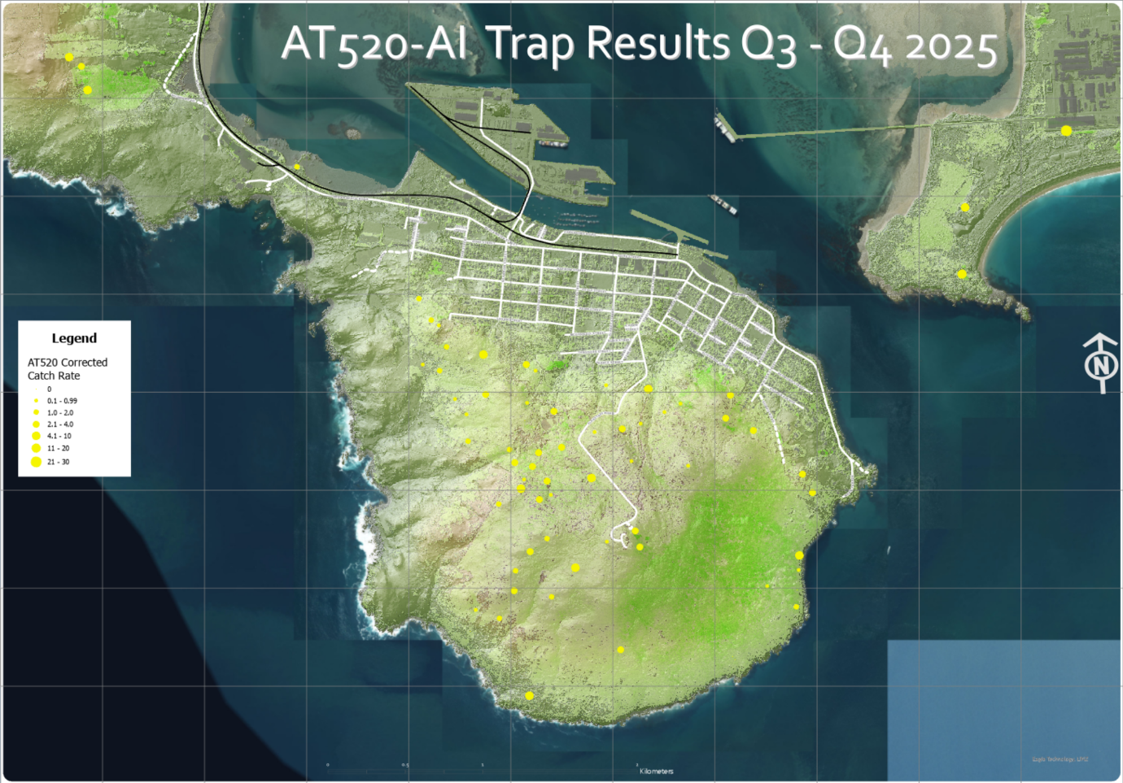
In the table below, the numbers show the totals across the Motupōhue traps.
Trap Type | Number of Trap Type | Possum CCR | Possum Kills | Possum Kills per trap | ‘Small’ CCR | Small Kills | Small Kills per trap | Total CCR | Total Kills | Total Kills per trap
AT220 | 104 | 0.17 | 32 | 0.31 | 6.08 | 1,124 | 10.80 | 6.24 | 1,156 | 11.11
AT520 | 64 | 0.04 | 6 | 0.09 | 4.63 | 296 | 2.54 | 2.52 | 302 | 4.72
There is no easy explanation for this anomaly. As can be seen from the maps, the AT220 and AT520 traps occupy very similar areas of the hill (and to be clear, the table above only looks at traps on Motupōhue – it does not include Tiwai or the area to the north of the isthmus).
The difference in possum triggers in particular is striking – 32 AT220 triggers compared to just 6 by AT520s. The AT520 triggers are verified kills.
The AT520-AI data includes trigger counts from both the trap node and the PCB. When the data was analysed, there was no significant difference in the results. This demonstrated that the PCBs in the AT520 traps was not generating spurious results. It is important to note that the PCBs in the AT520 traps are all newer-version v11.1 PCBs produced in 2024. All of BHMET’s AT220s are using older v9.1 PCBs produced in 2022. It is therefore possible that the spurious results are only generated by these older PCBs.
This will take further analysis to reach a firm conclusion.

Comparison of Results
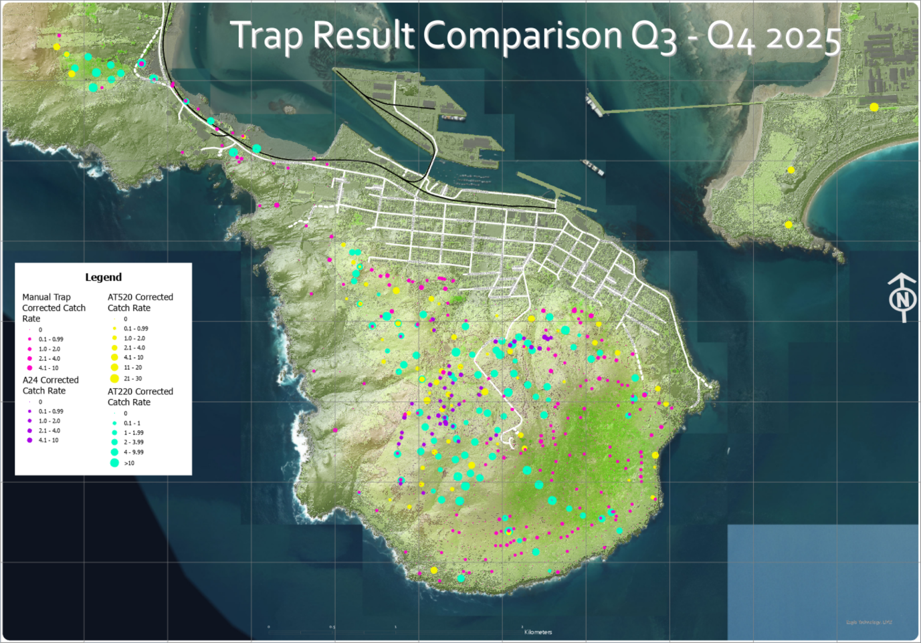

AT110 Trial
BHMET has been trialling 16 of the prototype AT110 ground-based automatic traps from NZ Autotraps. These traps use a similar mechanism to the AT220 but use a tunnel architecture which should make them more attractive to mustelids.
The trial started in July 2025 and there is very little to report. The traps are killing at a higher rate than DOC200 traps – but mostly killing rats with a low mustelid kill rate.
BHMET has made suggestions to NZ Autotraps about potential improvements to increase the kill rates: changing the location of the lure dispenser to each end of the trap instead of the middle; adding ramps to either end; and making the roller more likely to roll the carcass out of the trap.

Monitoring
Since Environment Southland stopped all predator and bird count monitoring in 2024, BHMET has had to rely on its own monitoring resources. We explored the option of continuing with tracking tunnel and bird county monitoring but rejected this as a very imprecise measure of activity – both methods are essentially ‘point’ checks which cannot take into account weather conditions.
Therefore BHMET has been using the latest monitoring technologies:
- AT 520-AI traps
- Yarn Trail Cameras
- Cacophony AI bird monitors.
In addition, we were fortunate in that Manaaki Whenua (Landcare Research), a Crown Research Institute, undertook research that involved placing trail cams to identify predator activity around AT220 and AT520 traps.

AT520-AI Traps
One of the key capabilities of the AT520 trap is that trap interactions are recorded in near real-time. Each trap is therefore monitoring species presence.
This capability is supposed to be supported with AI providing an automatic identification of species. However, the AI had proven highly inaccurate. This has two impacts. The first is the inability to use the Species Selective Arming capability (i.e. using the AI identification to arm the trap when a predator is identified). But the second is that the AI identification can’t be used to automate the collection of data. Therefore, the monitoring data can only be collected by manually reviewing every single image. Each trap produces thousands of images per month; BHMET has 105 AT520 traps and we monitor another 50 traps and 32 trail cams for other organisations. This takes a lot of time and is unaffordable in the long term.
Setting aside the significant cost of collecting the data, the results have been extremely useful. It is now possible to measure predator presence daily – in effect gathering RTI and RTC statistics on a daily basis.

Trap Interactions Analysis
A key aspect of trap performance is the manner of target species interaction with the trap prior to being killed. Ideally, a predator encounters a trap, investigates the trap and is killed on that first visit – this would be defined as a high-interaction trap.
The reality for most traps is rather different. Predators will visit a trap many times, gradually becoming more comfortable with the trap before entering the trap and being killed.
We wanted to better understand interactions with our AT220 and AT520 traps. Fortuitously, Manaaki Whenua (Landcare NZ), a Crown Research Institute, was conducing research into possum interactions with automatic traps and had established two trail cams pointing at each of 10 AT220 and 10 AT520 traps on Omaui and Motupōhue. One of these cameras was set to take time lapse images every 10 minutes, the other to take a 10 second video when motion was detected.
Using the trailcam video, we are able to analyse the videos recorded outside the traps and compare them with the images taken by the AT520 cameras inside the traps.
For each AT520 equipped with a trail camera, we classified animal-trap interactions on a scale from 0 to 6. A score of 0 corresponds to an animal passing near the trap without showing any interest, whereas a score of 5 corresponds to an animal entering the trap, and 6 to a confirmed kill. The camera records were collected from 17/07/2025 to 21/10/2025.
This approach allows us to estimate how many interactions, on average, lead to a capture.
The graphs below were obtained:

Shan0600CM(CAM625)
The first graph shows interactions recorded with the external trail cam. There were many possum sightings (probably all the same animal), but no interactions close to the trap. We also detected one rat, but with minimal interest in the trap.
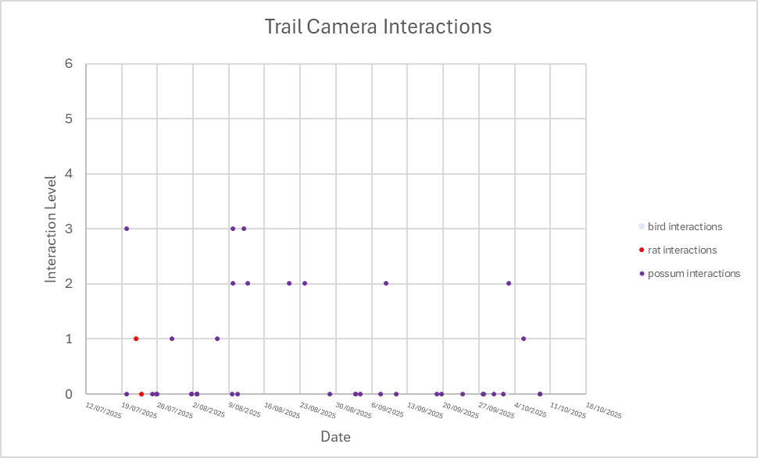 The second graph shows interactions recorded with the AT520’s internal camera. Nothing was seen until 11th September, after which there were many waxeyes seen in the trap feeding from the bait cup. None of the birds were observed by the trail cam – they are too small to trigger the motion detector. Birds were kept safe because the trap is disarmed during the day. The lack of activity before 11th September was because the trap was set to not record daytime interactions. None of the possum or rat interactions were seen (these were all nighttime interactions and would have been seen except they were too far below the trap.

Motu1300CM(CAM487)
Motu1300CM is located in a much quieter area. Only a very few rats were observed during the period – possibly just a one or two individuals. The graph below shows only a couple of rat interactions with the trap. One cat approached the bottom of the trap but did not enter.
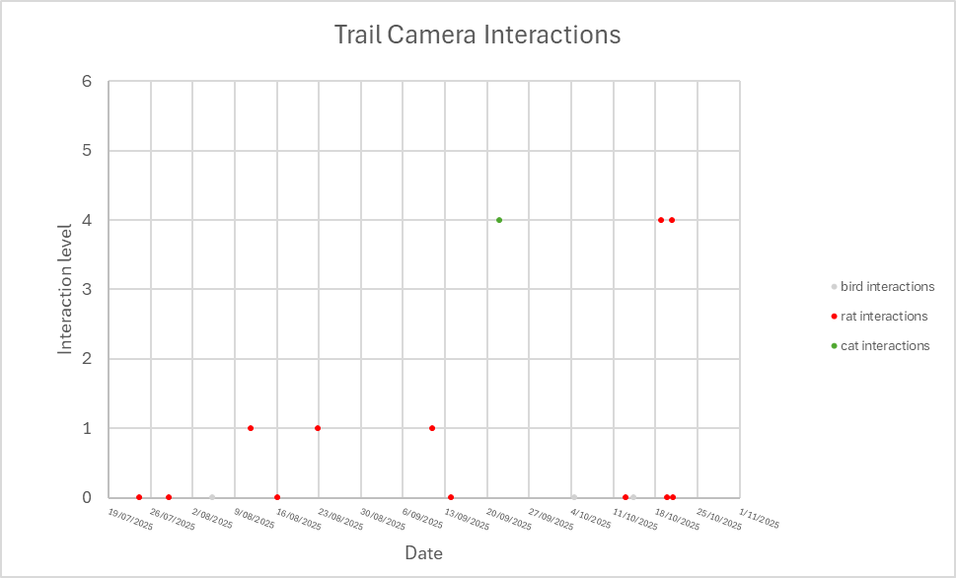
The graph below is from the AT520 internal camera and shows a surprising result. This shows rats entering and being killed in the trap – interactions that were not observed in the trail cam footage. The trail cam was set up to only observe the lower half of the trap so it is surmised that the rat entered the trap from the top and therefore failed to activate the motion detection. Bird interactions start on 11th September and there was then a waxeye kill when the bird entered the trap before dawn before daylight safe
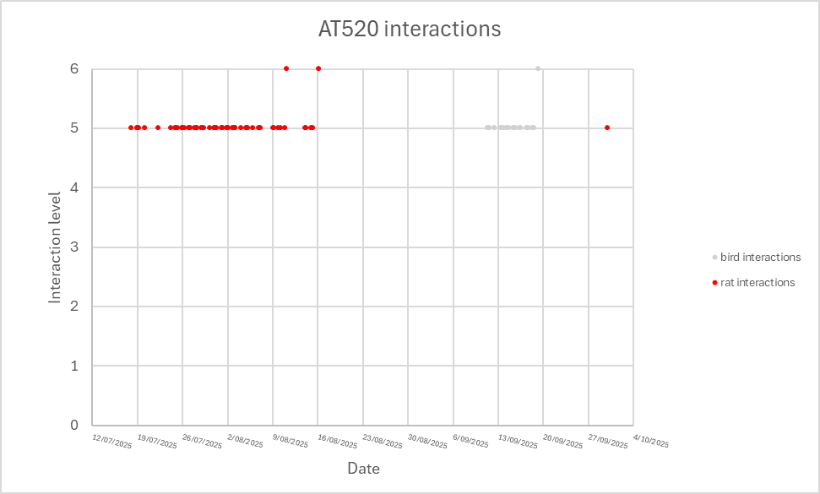

Taur0070CM(CAM589)
Taur0070CM is situated on an area of regenerating native bush and gorse. The results in the graph below show a lot of bird activity (blackbirds and thrushes) on the ground underneath the trap. There were then a handful of possum, cat and stoat interactions – none of them entering the trap. No rats were observed in the trail camera footage.
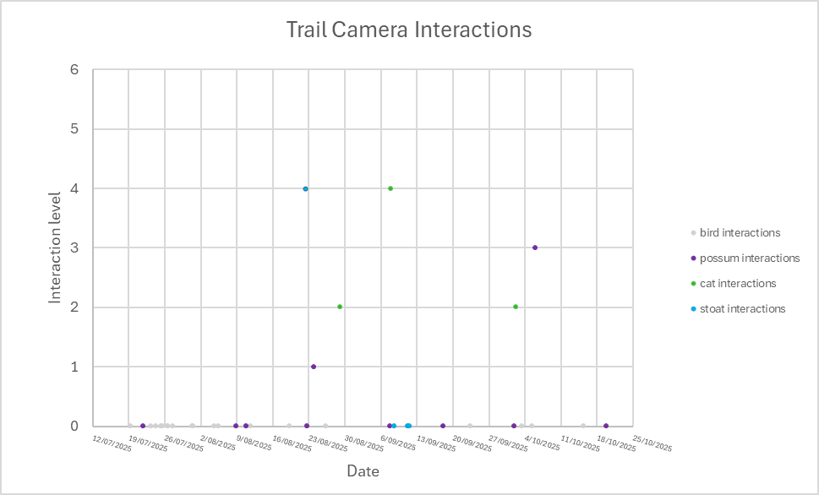
The graph below shows results from the AT520 internal camera. Rats were observed inside the trap and there were three kills. The rat activity was not seen in the trail camera because the camera was trained at the bottom of the trap and the rats almost certainly entered the trap from above. Waxeye activity only started on 11th September when the daylight sensor was enabled.
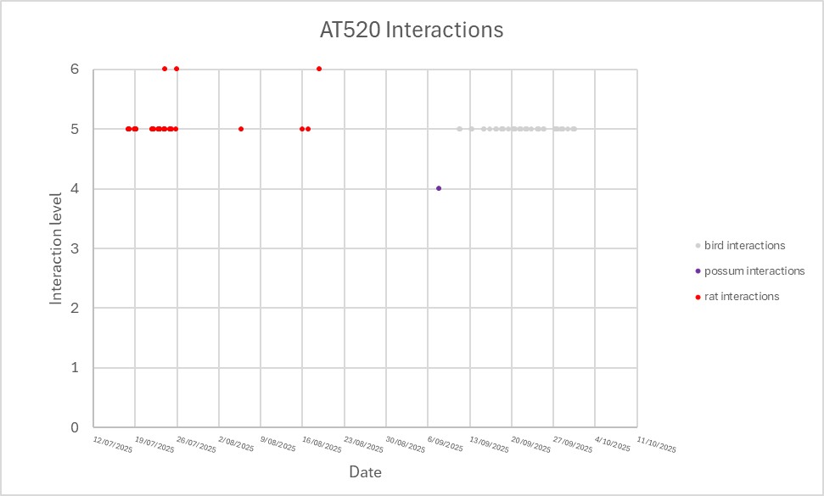

BLine0550CM(CAM416)
Bline0550CM is located in an area of dense manuka bush. The graph below shows a lot of waxeye activity inside the trap with rare cat, rat and possum activity.
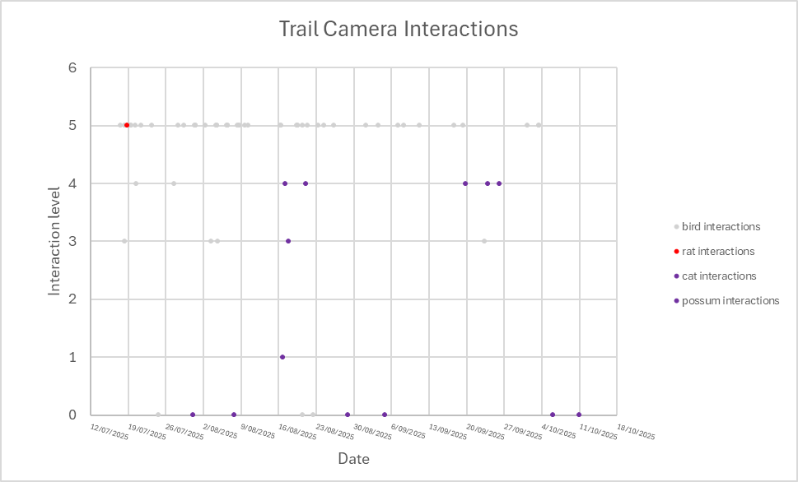
The graph below shows the interactions recorded on the AT520 internal camera. Three rats were killed – only one rat had been seen inside the trap in the trail cam footage. Waxeye observations started on 11th September when the daytime sensor was enabled.

Interaction Analysis Conclusions
We were surprised at the number of interactions that typically precede a kill – it is far higher than we had expected.
It is important to note that the AT520 only captures images of level 5 and 6 interactions (i.e. inside the trap) regularly. It only sees possum and cat interactions at level 4 (just under the trap). The majority of interactions recorded on the trail cams were levels 0-3.
This raises the question whether AT520 is a valid source of monitoring data. We believe that it is no less valid than tracking tunnel monitoring; it would be naïve to assume that all predators walk through the tunnels; many will bypass.
Trail cam monitoring would in theory be a more accurate means of monitoring but even trail cams miss activity.
For now, the AT520-AI provides a valuable balance between accuracy and affordability.

Yarn AI Trail Cams
BHMET received 32 AI Trail Cams from FTP Solutions in July 2025. This was considerably later than had been planned. These have been deployed throughout the trapping area and have been included in the overall AT520 monitoring data.
Unfortunately, the AI for the trail cams has proven even more problematic than for the AT520-AI traps, meaning that the data must be processed manually. BHMET will continue to work with FTP Solutions to improve the AI performance.
One particular use for these trail cams has been to monitor the tītī colonies on Motupōhue. Trail cams were deployed at the burrows and along the trails through the forest leading to the take-off points on the Foveaux Walkway. This monitoring has shown that the one monitored colony is thriving with no obvious sign of predation. It is planned in future years to conduct more thorough monitoring to collect data on more of the colonies to get a better understanding of the overall health of the colonies.

Cacophony AI Bird Monitor
In March 2025, BHMET acquired eight Cacophony AI Bird Monitors. These have proved more challenging to operate than had been anticipated. The AI functionality has an extremely low identification rate, and it hasn’t been possible to determine species distribution across the hill.
We are uncertain why the identification rate is as low as it is. Bird song has regional dialects, and it is possible that an AI that has largely been trained on the North Island is struggling to understand the ‘accents’ of the deep South.
Unfortunately, there was insufficient time or expertise to manually classify the recorded bird song data and the decision was therefore made to abandon the bird monitoring for now. This was a frustrating failure.

Nursery Operations
Nursery operations continued apace in Q3-4. 25,000 qualifying plants have grown well and are ready for planting in 2026. The watering system is much improved and has required far less intervention.
The rear nursery fence was finally replaced in October – the day before a major storm which loosened the footings. The contractor beefed up the footings and the fence is now secure.

Planting

Current Planting Season
The autumn was warm and dry, delaying the start of planting until May. After that delayed start, the planting season went extremely well, attracting many groups of individual and corporate volunteers.
Corporate groups have once again dominated the planting effort with Ballance, Awarua Whanau Services, the Department of Conservation, Great South and the NZ Abalone Company sending teams to help with the mahi.
Planting was done on a number of sites, some completing from previous years, others involving clearance of weed-infested areas. Most plantings have done well in the cool, wet weather of 2025. The major storm of October 23rd 2025 tested the plantings – most of which did well now that we have stopped using plant protectors.
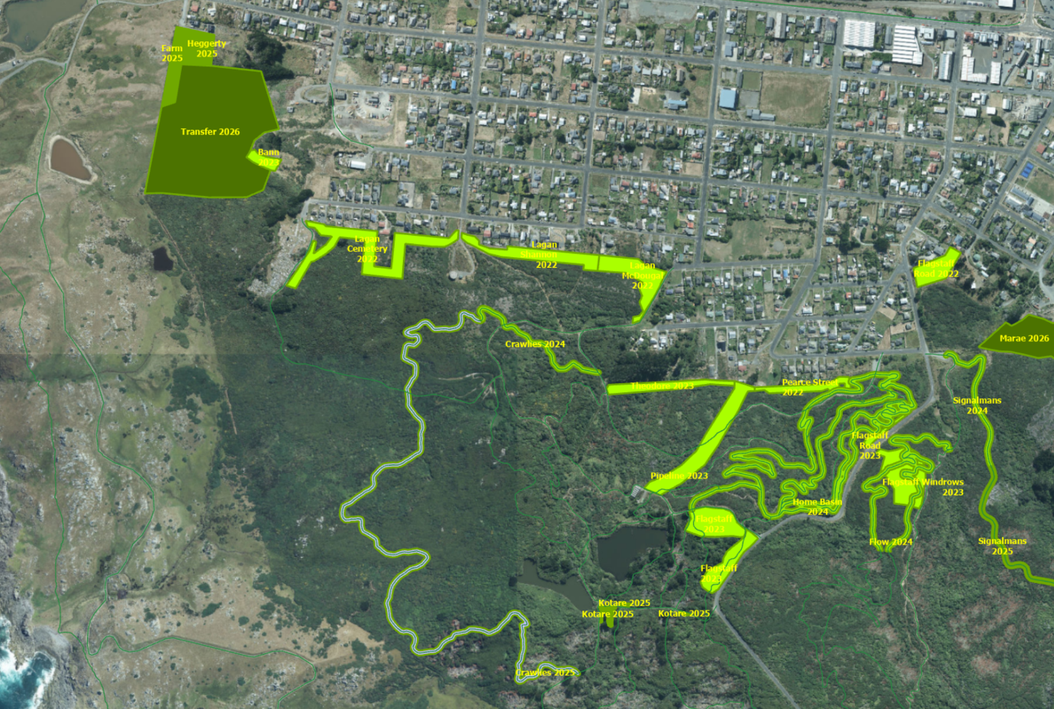
Planting continues to be a key source of BHMET’s Social License to Operate.

Past Plantings
We continue to maintain previous years’ planting areas. In most areas, the plantings have outpaced weed growth (and indeed have greatly benefited from the shelter and mulching effect of weeds). Lupins have proven a major challenge in the Kirk Crescent planting area and have required considerable effort to control using Department of Corrections Community Service offenders.
The 2022 plantings around the gun emplacement have proven to be the most spectacular of all prior year plantings. This was a community planting originally planned to celebrate the Queen’s platinum jubilee. Sadly, she died the week before and so it was a positive way to bring the community together to celebrate her life. These trees are now well over 3m tall and extremely healthy.

